**Appendix S1**

**Blooms and flows: Effects of variable hydrology and management on reservoir water quality**

Kristin J. Painter1*, Jason J. Venkiteswaran2, and Helen M. Baulch1

1 School of Environment and Sustainability, Global Institute for Water Security, University of Saskatchewan, Saskatoon, SK S7N 5C8, Canada

2 Department of Geography and Environmental Studies, Wilfrid Laurier University, Waterloo,

ON N2L 3C5, Canada

*Corresponding author: kristin.painter@usask.ca

Journal: Ecosphere

This appendix contains supplemental figures and tables for “Blooms and flows: Effects of variable hydrology and management on reservoir water quality”.

Figure S1. Daily hydrograph of Qu’Appelle River discharge (m3/s) recorded at Environment and Climate Change Canada hydrometric station 05JG006 (Elbow Diversion Canal at Drop Structure) downstream from Lake Diefenbaker, Saskatchewan (ECCC, 2022).

Table S1. Approximate significance of smooth terms (edf, ref.df, F and p-values) and description of overall model fit (adjusted R-squared and deviance explained) of generalized additive models of daily phycocyanin (RFU) over time (day of year)

|  |  |  |  |  |  |  |  |
| --- | --- | --- | --- | --- | --- | --- | --- |
| **Year** | **edf** | **ref.df** | **F** | **p-value** | | **R-sq. (adj.)** | **Deviance explained** |
| **2014** | 25.31 | 31.03 | 31.05 | <0.001 | 0.919 | | 94.3 |
| **2015** | 47.57 | 57.56 | 31.90 | <0.001 | 0.937 | | 96.1 |
| **2016** | 46.37 | 56.26 | 94.46 | <0.001 | 0.976 | | 98.4 |
| **2017** | 47.31 | 56.18 | 148.5 | <0.001 | 0.982 | | 98.7 |
| **2018** | 20.23 | 25.22 | 41.81 | <0.001 | 0.893 | | 91.0 |
| **2019** | 17.68 | 21.81 | 71.36 | <0.001 | 0.925 | | 93.5 |
| **2020** | 23.50 | 28.73 | 42.60 | <0.001 | 0.916 | | 93.4 |

Figure S2. Partial effects plots of smooth terms from generalized additive models fitted to phycocyanin (RFU) over time (day of year [DOY]) for A) 2014, B) 2015, C) 2016, D) 2017, E) 2018, F) 2019, and G) 2020. Partial residuals are shown as blue points and the shaded ribbon around the trend line represents 95% CI.

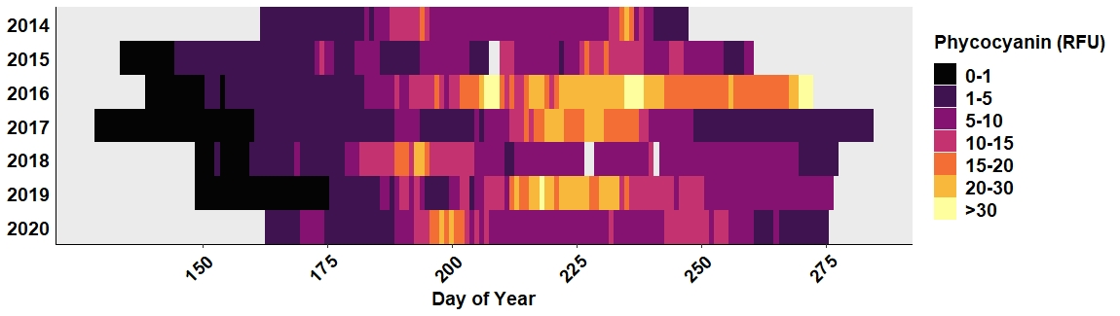

Figure S3**.** Heatmap showing daily phycocyanin (RFU) levels over the study years (2014 to 2020) in Buffalo Pound Lake. Phycocyanin increases from dark (e.g., black: 0-1 RFU) to light colours (light yellow: >30 RFU). Blank areas indicate no data was collected.

Figure S4. Scree plot of percentage of variance explained by each principal component (dimension) from principal components analysis of daily environmental variables (Table 2 in main article).

**REFERENCES**

Environment and Climate Change Canada (2022) Historical Hydrometric Data for Elbow Diversion Canal at Drop Structure (05JG006). Available online: <https://wateroffice.ec.gc.ca/search/historical_e.html>